APPENDIX 7B. CLYST HONITON NP DESIGN CODE

Janvrin Edbrooke Clyst Honiton PC 2020

Contents
Introduction 2
Design 2
Design in the Plan Area 2
Clyst Honiton Character Assessment (Appendix 7A) 3
Design Codes 4
Code 1. Setting: The Local and Wider Context. 5
Code 2. Built Form: Patterns of Growth and Layout of Buildings 5
Code 3. Built Form: Continuity and Enclosure. 6
Code 4. Built Form: Corner and Gateway Buildings. 7
Code 5. Built Form: Architectural details and Building materials 7
Code 6. Housing Extensions 13
Code 7 Prioritising Walking and Cycling 14
Planning Applications in the Parish: Issues to Consider and General Question to Ask when Preparing a Development Proposal 15
Issues to Consider: Hierarchy 15
First Check Step 16
General Questions to Ask 16

Introduction

Design
Recently design and achieving well designed places has come to the forefront in planning. The new NPPF in 2021 included a much altered section 12 which focuses on the production and utilising of design codes in the planning process and a key message that development that is not well designed should be refused.
Paragraph 127 of the NPPF (2021) highlights the role of Neighbourhood planning groups to
“play an important role in identifying the special qualities of each area and explaining how this should be reflected in development, both through their own plans and by engaging in the production of design policy, guidance and codes by local planning authorities and developers.”
A plethora of documents are now available to support NP groups involved in the production of design codes. The National Model Design Code¹ provides detailed guidance on the production of design codes, guides and policies to promote successful design.
Design in Clyst Honiton Plan Area
- The Clyst Honiton Neighbourhood Plan has produced a design code as well as policies to protect and enhance designs and landscape settings that the community value from the past,and present, and to encourage good design in all new developments in the future. By these means we wish to establish an approach that will ensure an attractive and sustainable built environment.
- There is no single, simple way of achieving good design, but a key message is that new buildings should be considered in the context both of their immediate surroundings and of the Plan Area as a whole. In order to achieve this, good design should endeavour to create places, buildings or spaces that work well for everyone, look good, last well and will adapt to the needs of future generations and climate change.

- New developments should seek to reflect local character and should take into account the enhancement and creation of built and open spaces, safe access, efficient use of natural resources and should help to create cohesive and vibrant neighbourhoods.

¹ https://www.gov.uk/government/publications/national-model-design-code

- The design policies and code embrace outstanding or innovative designs and encourages all new development to be more energy efficient with developments that include the harnessing of natural energy sources such as air, ground and solar.

- It is intended that this Design Code will be seen as a framework and guide for all built changes within the Plan Area . These principles will be an integral part of the planning process and would be used by the local community, householders, developers and statutory authorities when development, of whatever size, is proposed.
- This document has been prepared at the same time as the Neighbourhood Plan and is seen as a key appendix to be referred to in the planning application decision process. The principles that are fundamentally important to guide any development in Clyst Honiton Plan Area are based on: the analysis of local character presented in Appendix 7A and guidance from the latest National Design Guide.

Clyst Honiton Village Character Assessment (Appendix 7A)
- The Character Assessment is a description of the distinctiveness of the area covered by the Plan. It aims to communicate this by first dividing the area into distinctive character areas, then identifying the key features and characteristics that make the area distinctive. The character assessment is a key document in the Design Code.
- The character assessments in the Plan area are to be used to guide future developments to preserve or enhance or even change the character when opportunities arise through planning applications. Poorly designed development proposals are sometimes the result of a failure to appreciate the character of the area and so can fail to conserve or enhance the good character elements or fail to use the opportunity to improve poor character.
- The four areas of the village that have been identified are:
  - North Clyst Honiton
  - St Michaels Hill and Close
  - Clyst Honiton Centre
  - South Clyst Honiton

- Each character area is presented using the following headings:
  - Character including:
    - Layout and Spaces
    - Roads, Streets, and routes
    - Green and Natural Features
    - Landmarks
    - Streetscape
    - Buildings and details
  - Character strengths
  - Character weaknesses
This material provides a rich source of information which is to be utilised in the planning application decision making process by the Parish Council and LPA.

Design Codes
The following 7 design codes are to be considered in all development proposals. For new development within the four-character areas of the village the design principles of the development, where appropriate are to be in keeping with the sites location. For new developments outside these character areas the design principles of the development need to address Codes 1-5 and 7 and in time Code 6.

Code 1. Setting: The Local and Wider Context.
In the Plan Area the village and other communities have a strong relationship with the wider rural area from the ‘green horizon’ views to the green corridors that permeate settlements and communities and the routes that pass through. The ‘continuation’ of this wider rural setting should be reflected in any development proposals. The importance of green horizons and rural vistas was evidenced in community consultation to include this is Design Code 1
- New development proposals should be located away from ridge tops, upper valley slopes or prominent locations.
- New development proposals should not be visually intrusive. This can be achieved through the appropriate scale and design including screening.
- In any new development, buildings should be designed to respond to existing view corridors and/or reinforce views of existing landmarks.
- Development should also take the opportunity to enhance and/or create views, vistas and skylines and other features such as trees and hedgerows where possible. Where appropriate, development could develop and frame locally important views through the creation of boulevards or carefully placed gaps, providing interest with vistas beyond.
- New developments on the rural/ urban fringe should respect and reflect the rural character. The heights of proposed building should
be lower to accommodate views out onto the ‘green horizons.
- New development plans should contain details of existing site views and the selection of important views within, into and out of the site and to ensure protection of views to include both built and landscape heritage assets.

Code 2. Built Form: Patterns of Growth and Layout of Buildings
New developments should respect the particular buildings in place and the open space patterns of the area its located in which contribute positively to its character. In particular:
- Any new development in the Plan should be carefully sited to minimise negative impacts on the landscape.
- New developments must demonstrate an understanding of the scale, building orientation, enclosure, uniformity and façade rhythm of the surrounding built environment to respect its character.

- Large new developments with properties should show a variety of types. The use of a repeating type of dwelling along the entirety of the street should be avoided to create variety and interest in the streetscape, unless uniformity is a characteristic or the streetscene already in place.
- Boundaries such as walls or hedgerows, whichever is appropriate to the street, should enclose and define each street along the back edge of the pavement, adhering to a clear building line that can allow minor variations for each block of development style. The use of panel fencing is not recommended, especially for frontage boundaries.
- Where appropriate, new properties should aim to provide rear and front gardens. Where the provision of a front garden is not possible, small buffers to the public sphere such as planting strips are still beneficial and recommended.
- The layout of new development should optimise the benefits of daylighting and passive solar gains in order to significantly reduce energy consumption.
- Any proposal that would adversely affect the physical appearance of the surrounding character area and/ or give rise to an unacceptable increase in the amount of traffic, noise, or disturbance would be inappropriate. Developments should avoid car- dependent layouts based on the monotonous repetition of a uniform building typology.
- To enable character of a community key built form is provided for all the character areas listed in Appendix 7A.

Code 3. Built Form: Continuity and Enclosure.
The following principles serve as general guidelines that should be considered for achieving satisfactory sense of enclosure and continuity:
- Building façades should always front onto streets and public spaces such as parks, pedestrian and cycle routes.
- When designing building setbacks, façades should have an appropriate ratio between the width of the street and the building height.
- Buildings at the end of street should be designed to turn corners and terminate views.
- Long spaces can lack visual enclosure. Variation to the building lines and visual pinch points can be introduced to avoid this problem.
- The cross-sections of public spaces and the building elevations either side can be varied to create places with different visual character. Ratios of between 1:1.5 and 1:3 (building height/street width) will generally create spaces with a strong sense of enclosure. For a more intimate mews character, a minimum ratio of 1:1 could be adopted. Squares and courtyards with a ratio between 1:4 and 1:5 will create a feeling of enclosure.

Code 4. Built Form: Corner and Gateway Buildings.
One of the crucial aspects of a successful settlement form is the issue of corners and gateway buildings. Gateway and corner buildings are those that start a settlement/ road and create a local landmark. These buildings often have at least two public facing façades, so they have
double the potential to influence the street’s appearance. Therefore, the following principles apply to corner and gateway buildings. There are several policies in which buildings are or will be corner and gateway buildings. This policy will apply to policies C1, C2, E3, E4, SA2 and SA3, the latter will have 5 gateways buildings and 2 corner buildings)

- If placed at important intersections the building could be treated as a landmark and thus be slightly taller or display another built element, signalling its importance as a way - finding cue.
- The form of corner buildings should respect the local architecture character/s that improves the street scene and generates local pride.
- All the façades overlooking the street or public space should be treated as primary façades.
- The building should have some form of street contact in the form of windows, architecture, or outdoor private space.
- In the case of fencing for back gardens or perimeter walls, the quality of the materials should be high. Panel fencing should be avoided. Instead, different treatments should be used such as: dry wall or masonry walls which create patterns similar to the main building windows; patterns created with bricks; a green lawned area or bank ; hedges and planting; a combination of open timber structures and brick.

Code 5. Built Form: Architectural details and Building materials
Within the Plan Area there a variety of architectural styles and ages contributing to the character and appearance of settlements and communities, including early cob thatched properties, early 19th century; mid-to-late 19th century Victorian buildings; and a variety of 20th and 21st century styles. Such architectural styles and ages are closely linked with the building materials available and in vogue at that time. There are historic buildings include cob and a variety of stones, including heavitree stone and volcanic rock. A lot of properties are rendered, with the predominant colour being white, the other common finish is red brick. It is therefore important that the materials used in proposed developments are of a high quality and reinforce such local distinctiveness.
Key architecture features and use of local materials should be considered in future development proposals. In the village Character Assessment key architectural features and use of materials are provided in depth for each area and this should be used as a key resource. However, a few principles are provided below

- Any future development proposals should be based on an understanding of the surrounding built environment and demonstrate the local palette of colours and materials.
- Apart from the brick used in paving, high quality natural traditional stone materials are to be utilised to strengthen local identity.
- Any new materials should be durable, sourced from eco- friendly, recycled and sustainable supplies when possible.
- Below are some examples of building materials that contribute to the local vernacular within the Plan Area and are to be used to inform future development. This list is not exhaustive, and each design proposal should explain its material strategy and how it fits within the context of the area.
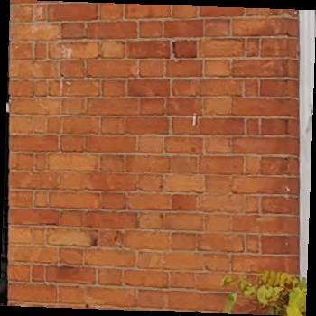 Orangey Red brick 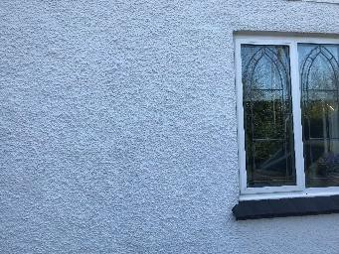 White Render

 Local volcanic purple
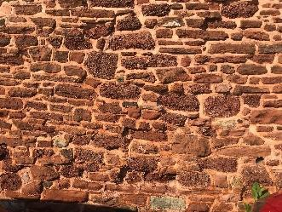 Heavitree Stone
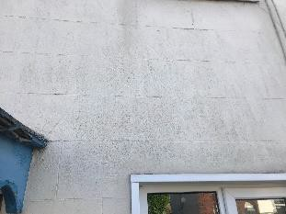 Painted stone

The images below show examples of houses from the village with these building materials and /or where materials are combined.

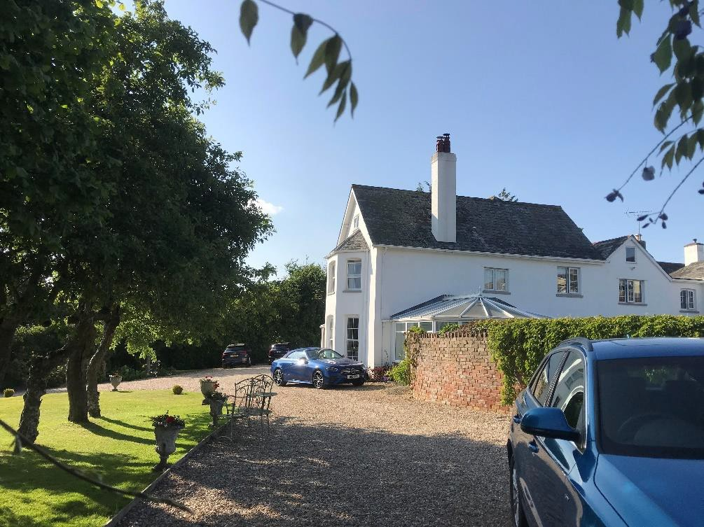
Render and heavitree stone

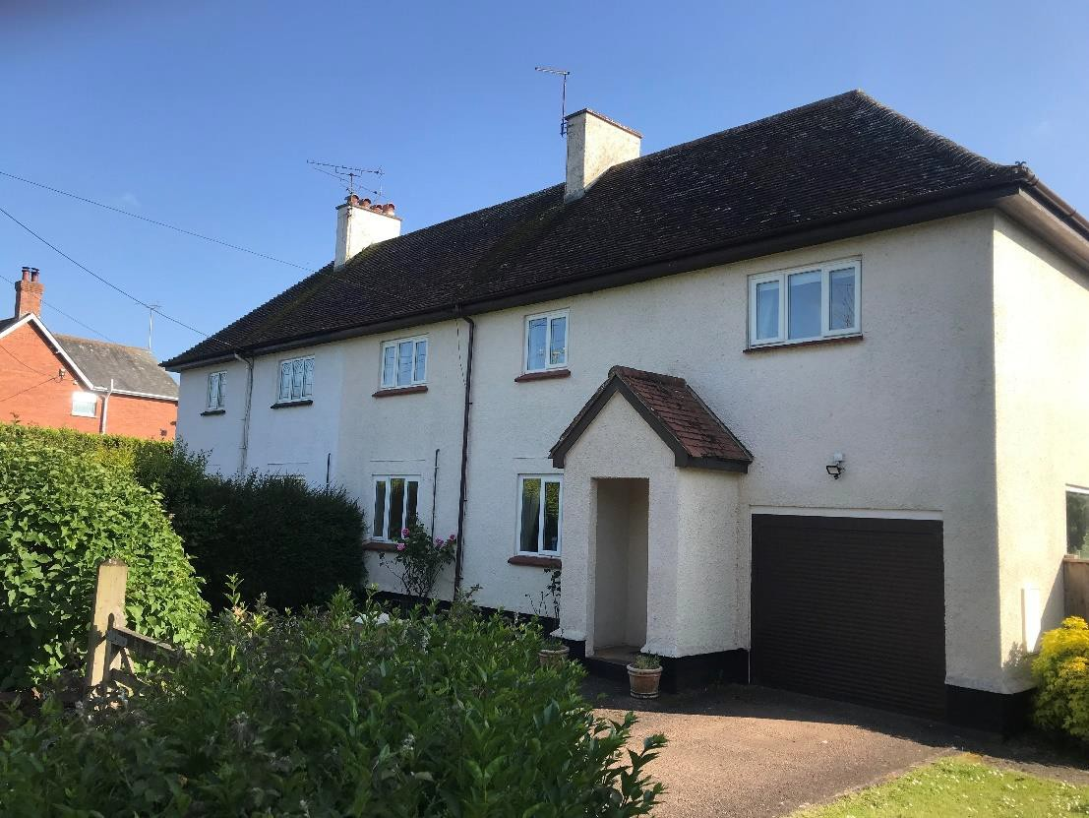
White and cream render

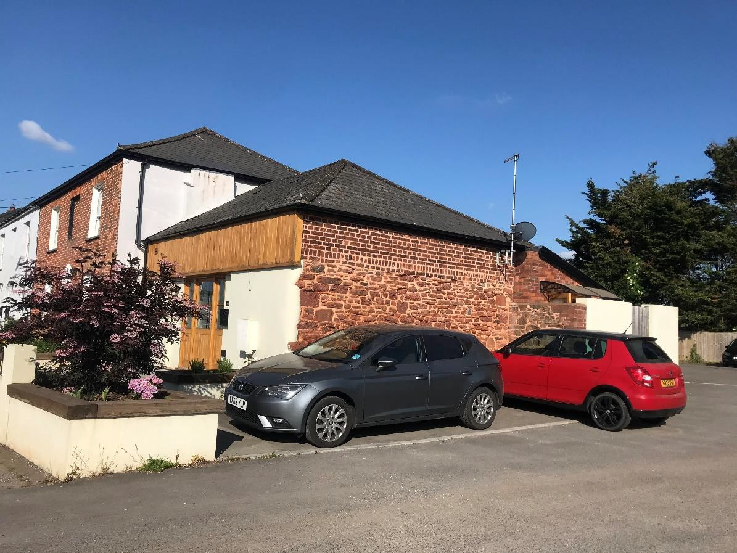
A very good example of render, heavitree stone and red brick being combined in a new build, which makes a good gateway site along York Terrace

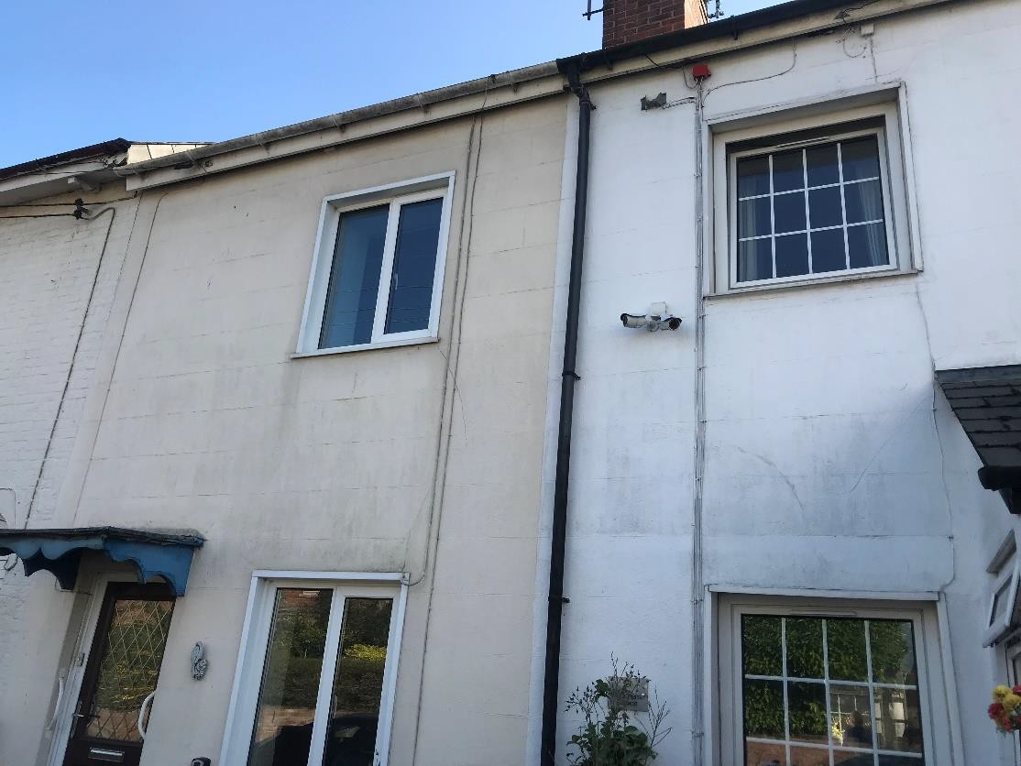
White and cream painted stone properties.

Code 6. Housing Extensions
It is recognised that many household extensions are covered by permitted development right and do not need planning permission. There are a number of principles that residential extensions requiring planning permission should follow to maintain character:
- The original building should remain the dominant element of the property regardless of the number of extensions. A newly built extension should not overwhelm the building from any given viewpoint.
- Extensions should not result in a significant loss to the private amenity area of adjacent dwelling/s.

- The pitch and form of the roof used on the building adds to its character and extensions should respond to this in areas where specific roof structures are appropriate.
- Extensions should consider the materials, architectural features, window sizes of the existing building and design an extension that matches and complements the existing building.
- In case of side extensions, the new part should be set back from the front of the main building and retain the proportions of the original building. This is in order to reduce any visual impact of the join between existing and new.
- In case of rear extensions, the new part should not have a harmful effect on neighbouring properties in terms of overshadowing, overbearing or privacy issues.

Code 7 Prioritising Walking and Cycling
With the Neighbourhood Plan there are a number of policies that are concerned with enabling and creating links that favour pedestrian and cycle connections. This means that streets should be connected with each other, and different travel options and routes should be considered. Good practice favours a connected street layout that make it easier to travel by foot, cycle, and public transport. These routes should benefit from natural surveillance, activity and paths with good sightlines and unrestricted views which make people feel safer.
This connected pattern creates a ‘walkable neighbourhood’; a place where streets are connected and routes link meaningful places together. There are a number of principles that residential and commercial developments should follow to enable prioritising walking and cycling:
- All newly developed areas must provide direct and attractive footpaths between neighbouring streets and local facilities. Streets must be designed to prioritise the needs of pedestrians and cyclists. Establishing a robust pedestrian network: a) across any new development; and b) among new and existing developments, is key in achieving good levels of connectivity within, into and out of any part of Parish.
- A fully connected network pattern should be part of new development proposals, and long streets with a cul-de-sac pattern should be avoided, unless access for pedestrians and cyclists is provided.
- A connected street network at all levels provides people with a choice of different routes and generally allows traffic to be distributed more evenly across the network rather than concentrated onto heavily trafficked roads.
- Level changes of pedestrian walkways should be avoided. When unavoidable, a raised pavement with railings could be introduced to areas with steeply rolling landforms, to create a pedestrian friendly environment.
- Short and walkable distances are usually defined to be within a 10 minute walk or a five mile trip by bike. If the design proposal calls for a new street or cycle/pedestrian link, it must connect destinations and origins.

- In addition, connected streets must always provide a safe and pleasant environment.
- It is important that, in the case of new developments, streets are integrated with green spaces.
- Design features such as barriers to vehicle movement, gates to new developments, or footpaths between high fences must be avoided or if required are to be constructed at minimum height level recommendations.
- The latest Police Secured by Design Guidelines² are to be considered in the layout and design of pedestrian and cyclist routes to ensure
against the “security of development being compromised by excessive permeability, for instance by allowing the criminal legitimate
access to the rear or side boundaries of dwellings, or by providing too many or unnecessary segregated footpaths”.

Planning Applications in the Parish: Issues to Consider and General Question to Ask when Preparing a Development Proposal
Because the design codes in this appendix cannot cover all design eventualities, this section provides a number of questions based on established good practice against which the design proposal should be evaluated. The aim is to assess all proposals by objectively answering the questions below. Not all the questions will apply to every development. The relevant ones, however, should provide an assessment as to whether the design proposal has taken into account the context and provided an adequate design solution.
The information below should not be a substitute for the design details found within the NP policies and in the Design Code. There is a hierarchy of issues to consider when preparing a development proposal.

Issues to Consider: Hierarchy
The First Step is a quick check list and general questions for developers to consider in the proposals.
The Second Step is to look at each Design Code and to check which design principles are important for this location in the Plan Area.
The Third Step to ensure that the proposals or design address the policies within the Neighbourhood Plan.

2
The Police Secured by Design Guidelines. Available at: https://www.securedbydesign. com/guidance/design-guides

First Check Step:
The following list and questions are therefore to be used as a first basic approach with the Design Code and Policies providing far greater depth of design requirements.
The proposals or design should:
  - Integrate with existing paths, streets, circulation networks and patterns of activity;
  - Reinforce or enhance the established village or smaller settlement character of streets, greens, and other spaces;
  - Respect the rural character of views and gaps;
  - Harmonise and enhance existing character areas in terms of physical form, architecture and land use; ( See App 7A)
  - Relate well to local topography and landscape features, including prominent ridge lines and long-distance views;
  - Reflect, respect, and reinforce local architecture and historic distinctiveness;
  - Retain and incorporate important existing features into the development;
  - Respect surrounding buildings in terms of scale, height, form and massing;
  - Adopt contextually appropriate materials and details;
  - Provide adequate open space for the development in terms of both quantity and quality;
  - Incorporate necessary services and drainage infrastructure without causing unacceptable harm to retained features;
  - Ensure all components e.g. buildings, landscapes, access routes, parking and open space are well related to each other;
  - Make sufficient provision for sustainable waste management (including facilities for kerbside collection, waste separation, and minimisation where appropriate) without adverse impact on the street scene, the local landscape or the amenities of neighbours; and
  - Positively integrate energy efficient technologies.

General Questions to Ask
Here are a number of questions related to the design guidelines.
Street grid and layout
- Does it favour accessibility and connectivity over cul-de-sac models? If not, why?
- Do the new points of access and street layout have regard for all users of the development; in particular pedestrians, cyclists, and those with disabilities?
- What are the essential characteristics of the existing street pattern? Are these reflected in the proposal?
- How will the new design or extension integrate with the existing street arrangement?

- Are the new points of access appropriate in terms of patterns of movement?
- Do the points of access conform to the statutory technical requirements?

Green spaces, views and character
- What are the particular characteristics of this area which have been taken into account in the design; i.e. what are the landscape qualities of the area?
- Does the proposal maintain or enhance any identified views or views in general?
- How does the proposal affect the trees on or adjacent to the site?
- Has the proposal been considered within its wider physical context?
- Has the impact on the landscape quality of the area been taken into account?
- In rural locations, has the impact of the development on the tranquillity of the area been fully considered?
- How does the proposal affect the character of a rural location?
- How does the proposal impact on existing views which are important to the area and how are these views incorporated in the design?
- Can any new views be created?
- Is there adequate amenity space for the development?
- Does the new development respect and enhance existing amenity space?
- Have opportunities for enhancing existing amenity spaces been explored?
- Will any communal amenity spaces be created? If so, how will this be used by the new owners and how will it be managed?

Buildings layout and grouping
- What are the typical grouping of buildings
- How have the existing groupings been reflected in the proposal?
- Are proposed groups of buildings offering variety and texture to the townscape?
- What effect would the proposal have on the streetscape?
- Does the proposal maintain the character of dwelling clusters stemming from the main road?
- Does the proposal overlook any adjacent properties or gardens? How is this mitigated?

Building line and boundary treatment
- What are the characteristics of the building line?
- How has the building line been respected in the proposals?

- Has the appropriateness of the boundary treatments been considered in the context of the site?

Building heights and roofline
- What are the characteristics of the roofline?
- Have the proposals paid careful attention to height, form, massing, and scale?
- If a higher than average building is proposed, what would be the reason for making the development higher?
Household extensions
- Does the proposed design respect the character of the area and the immediate neighbourhood, or does it have an adverse impact on neighbouring properties in relation to privacy, overbearing, or overshadowing impact?
- Is the roof form of the extension appropriate to the original dwelling (considering angle of pitch)?
- Do the proposed materials match those of the existing dwelling?
- In case of side extension, does it retain important gaps within the street scene and avoid a ‘terracing effect’?
- Are there any proposed dormer roof extensions set within the roof slope?
- Does the proposed extension respond to the existing pattern of window and door openings?
- Is the side extension set back from the front of the house?
Building materials and surface treatment
- What is the distinctive material in the area, if any?
- Does the proposed material harmonise with the local materials?
- Does the proposal use high-quality materials?
- Have the details of the windows, doors, eaves, and roof been addressed in the context of the overall design?
- Do the new proposed materials respect or enhance the existing area or adversely change its character?
Architectural details and contemporary design
- If the proposal is within a conservation area, how are the characteristics reflected in the design?
- Does the proposal harmonise with the adjacent properties? This means that it follows the height, massing, and general proportions of adjacent buildings and how it takes cues from materials and other physical characteristics.
- Does the proposal maintain or enhance the existing landscape features?
- Has the local architectural character and precedent been demonstrated in the proposals?
- If the proposal is a contemporary design, are the details and materials of a sufficiently high enough quality and does it relate specifically to the architectural characteristics and scale of the site.

